**Bash Scripting Tasks**

1. Create a Bash script to check if a directory is available or not.

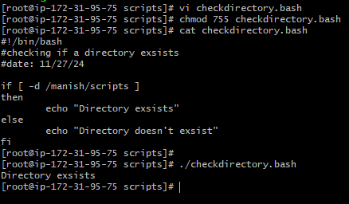

1. Create a Bash script which will create multiple files.

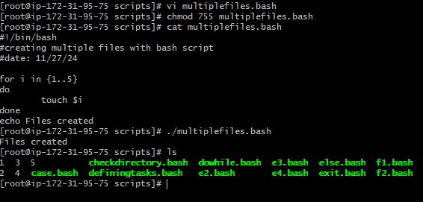

1. Create a Bash script to take backup of a directory.

